**LAB-14**

**Exercise:**

1) Implement the above code and paste the screen shot of the output. **a) Sequential**

**PROGRAM:**

|  |
| --- |
| #include <stdio.h>  #include <stdlib.h>  #include <conio.h>  int main() { int f[50], i, st, j, len, c;    // clrscr(); for (i = 0; i < 50; i++) f[i] = 0;  do { printf("\nEnter the starting block and length of the file: "); scanf("%d %d", &st, &len);  int allocated = 1;  for (j = st; j < (st + len); j++) { if (f[j] == 0) { f[j] = 1; printf("\n%d -> %d", j, f[j]);  } else { printf("\nBlock %d is already allocated!", j); allocated = 0; break;  }  }    if (allocated) printf("\nThe file is allocated to disk.");    printf("\nDo you want to enter more files? (1 = Yes / 0 = No): "); scanf("%d", &c);    } while (c == 1);    getch(); return 0;  } |

**OUTPUT:**

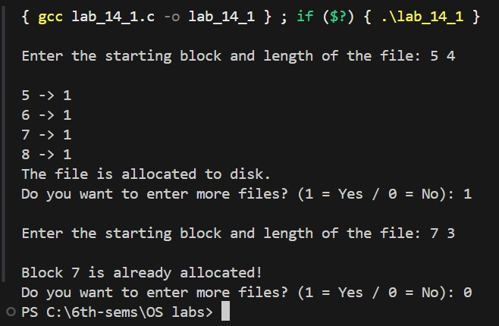

1. **Indexed**

|  |
| --- |
| #include <stdio.h>  #include <stdlib.h>  #include <conio.h>  int main() { int f[50], i, j, k, indexBlock, n, c, inde[50];    // clrscr(); for (i = 0; i < 50; i++) f[i] = 0;  do {  printf("\nEnter index block: "); scanf("%d", &indexBlock);    if (f[indexBlock] == 0) { f[indexBlock] = 1;  printf("Enter number of blocks on index: "); scanf("%d", &n);  printf("Enter block numbers:\n"); for (i = 0; i < n; i++) scanf("%d", &inde[i]);  int allocated = 1;  for (i = 0; i < n; i++) { if (f[inde[i]] == 1) { printf("Block %d is already allocated!\n", inde[i]); |
| allocated = 0; break;  }  }  if (allocated) { for (j = 0; j < n; j++) f[inde[j]] = 1;  printf("File Indexed.\n"); for (k = 0; k < n; k++) printf("%d -> %d : %d\n", indexBlock, inde[k], f[inde[k]]); }    } else { printf("Index block already allocated!\n"); }  printf("Enter 1 to enter more files and 0 to exit: "); scanf("%d", &c);    } while (c == 1);  getch(); return 0;  } |

**OUTPUT:**

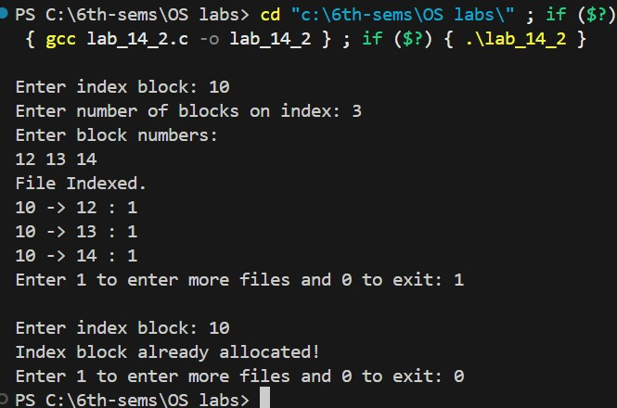

1. **Linked**

|  |
| --- |
| #include <stdio.h>  #include <stdlib.h>  #include <conio.h>  int main() { int f[50], p, i, j, a, st, len, k, c;  clrscr(); for (i = 0; i < 50; i++) f[i] = 0;  printf("Enter how many blocks are already allocated: "); scanf("%d", &p);  printf("Enter the block numbers that are already allocated:\n"); for (i = 0; i < p; i++) { scanf("%d", &a); f[a] = 1;  } do { printf("\nEnter the starting index block and length: "); scanf("%d %d", &st, &len);  k = len;  for (j = st; j < (st + k); j++) { if (f[j] == 0) { f[j] = 1; printf("\n%d -> %d", j, f[j]);  } else { printf("\n%d -> Block is already allocated", j); k++;  }  }  printf("\nDo you want to enter one more file? (1 = Yes / 0 = No): "); scanf("%d", &c);    } while (c == 1);  getch(); return 0;  } |

**OUTPUT:**

